***Ant-thology of Interest***:

Morphological Feature Size and Food Preference of Ant Species in Guadarrama Mountain Range of Central Spain

Gabe Guzman, Anna Imrie, Alexis Jones, & Aiden Ludka

ES 211: Ecology

Tasha Gownaris

2022, December 6

**Abstract**

This paper was inspired by previous analysis of the morphology of ants in relation to temperature and elevation as well as food resource preference in the Guadarrama mountain range in Central Spain. Based on this literature and their datasets we formulated two hypotheses. Using RStudio, we wrote code to determine if our hypotheses were significant. Hypothesis 1 states that the morphological features (eye, head, leg, and scape size in mm) of ants will be on average, greater at higher altitudes in the Guadarrama mountain range. Using a linear model, our hypothesis was found to be statistically significant, although in the opposite direction. All measurements were smaller at higher elevations. Head, leg, scape, and eye had R2 values of 0.194, 0.03, 0.04, and 0.12 respectively. This analysis and conclusion leave room for future study of whether the correlation between size and elevations is generalizable to all other ants species, or only to the subjects found in the Guadarrama Mountains. Hypothesis 2 states that different ant species will exhibit niche partitioning in their food sources (sugar, crickets, worms, and seed). An ANOVA test determined the relationship to not be statistically significant with a p-value of 0.89, df of 31, and F-statistic of 0.117t. Competitive exclusion states that two species can not occupy the same space indefinitely which supports our second hypothesis. Future research can work to determine if the spatial separation of the ant species is due to equal competitive viability or due to a small number of competitively-dominant specialists.

**Keywords:** Ants, altitude, niche, competitive exclusion, morphological variability, generalism, Spain, Guadarrama Mountains, entomology

**Introduction**

The principle of competitive exclusion asserts that two species within the same ecological niche--in other words, requiring the same biotic or abiotic resources to thrive--cannot coexist permanently. As a result of these limitations, many sympatric species will evolve to coexist with one another in distinct realized niches. These distinctions often involve spatial separation or resource partitioning, reducing the amount of interaction between species, even if they have the capacity to take over more resources if given the competitive high ground. Studying the role that organisms play in their environment is vital to the understanding of how they function. When we understand the interaction different species have, we can then go on to understand the interaction between humans and those species as well. For example, a case study on three different wolf species in Brazil focusing on niche separation found that in 1999, their diets were analyzed to understand niche breadth and degree of overlap. They hunted in separate territories of Emas national park to reduce competition (De Almeida Jácomo et al., 2004).

In this study, our mission is to analyze dietary coexistence as it relates to ants in the Guadarrama Mountains of Spain through two hypotheses. Hypothesis 1 states that the morphological features (eye, head, leg, and scape size in millimeters) of ants will be greater on average at higher altitudes of the mountain range. We expect to see a positive correlation between all body measurements and altitude, since the instability of a colder environment with less oxygen available would likely require expanded lung capacity and surface area for the absorption of heat. Hypothesis 2 states that different genuses of ants will exhibit niche partitioning in their food sources (sugar, crickets, worms, and seed). We expect analyses of food traps to reveal that different genuses have adapted different food preferences to avoid indirect “exploitation” competition.

Ants function as a perfect case study for niche diversification because of their massive level of intraspecific morphological variability, which provides plenty of opportunity to look for character displacement within a niche. Additionally, ants can be found in every region except the Arctic and Antarctic, Iceland, Greenland, and some isolated islands, so any results relating to the partitioning of their niches is generalizable for the majority of ecosystems on Earth (TNWF, 2007).

Analyzing the link between ecosystemic factors and resulting morphological changes can also be used to explore how greater climate shifts (e.g. higher temperatures, more intense dry seasons) might impact keystone species at a lower trophic level. Entomological studies looking at physiological ecology of ants (Group: Hexapoda), as well as the resource preference for this group, helps us better understand the effects of different environmental pressures. There are vast studies on ants and body size in general; however, according to Silvestre, there are limited sources and previous research on the comparison between ants body size, mountain habitat and food source (Silvestre et al., 2021). Therefore, Silvestre’s analysis will give scientists more insight on the size of body parts from each ant species specific to the central Spanish mountain range. Analyzing the sustenance that each ant species ingests allows us to acknowledge the ecological living situation that is required of them. Better understanding the effects of environmental pressures such as altitude and resource availability may help us in the understanding of the needs of ants and how different body sizes allow ants to survive.

**Methods**

***Study site***

Both data sets were collected in the Guadarrama Mountains of Central Spain Madrid. The Guadarrama Mountains are located within the larger collection of mountains in the Sistema Central (**Figure 1**). Sierra de Guadarrama has an elevation of 7,966 ft (Haub, 2021). In addition to the Mediterranean climate, the mountains also have Mediterranean elevation temperature patterns with lower temperatures and increased moisture at higher elevations and dryer conditions near the base of the mountain (Schöbe et al., 2013 Quoted in Silvestre et al., 2021). Mean rain patterns range from 550 - 1500mm and temperature varies based on elevation change with lower elevation having a mean temperature of 15℃ and dropping to 4℃ at the peak of the mountain (Ninyerola et al 2005 Quoted in Silvestre et al., 2021).

***Data Collection and Datasets***

Hypothesis 1 regarding ant morphology in relation to temperature and elevation was developed based on the data from Sivelstre, et. al, *Diverging facets of grassland ant diversity along a Mediterranean elevation gradient*. The following data collection analysis was taken from Sivelstre, et. al. The data was collected in the grassland during the summer season of July due to high ant activity at six elevations ranging from 640-2352 m. Each site had three 20 X 15 m plots with 50 m in between each. In each plot there were 12 traps that were buried and contained an ethanol and ethylene mixture to preserve it. Ants were categorized and worker and reproductive ants were excluded (Silvestre et al., 2021). The dataset used to code for our hypothesis included altitude, site number, plot letter, mountain location, species, number of individuals, eye, head, leg, scape, and a label synthesizing all of this information.

Hypothesis 2 regarding ant food resource preference was based on *Abiotic controls, but not species richness, shape niche overlap and breadth of ant assemblages along an elevational gradient in Central Spain* (Seoane et. al, 2021). The following data collection analysis was taken from Seoane et. al, 202l. Their data was collected within six 100X100 m study sites with elevation ranges of 684-2352 m. Food resource levels consisted of sugar water, live crickets, dry worms, and seeds which were offered in petri dishes with 1.5 cm openings. Eating periods were divided into six-hour time intervals and labeled as morning, afternoon, evening, and night. Five petri dishes of each resource were placed per location and covered with a plastic green mesh covering to prevent larger mammals from removing the food resources. The dishes were monitored to see if they had been eaten and refill if needed. The data was collected between late July and early August due to summer having high activity at all elevations. The dataset used to code for our hypothesis included site name, resource type, time period of trapment, and species type.

***Morphological Feature Calculations***

Data was analyzed using RStudio Desktop. The packages ‘tidyverse’, ‘rstatix’ and ‘ggplot’ were used in order to facilitate coding, aid in calculations for statistical significance in the data and to visualize represent results respectively. Once downloaded and installed, a linear model was created for every ant trait and altitude to test for statistical significance. Excel was used to summarize the output of these statistical tests. Linear regression plots were created to visually show the relationships between altitude and the size of the different morphological features.

***Species-based Resource Preference Calculations***

Data was analyzed using RStudio Desktop. The packages ‘tidyverse’, ‘rstatix’ and ‘ggplot’ were used in order to facilitate coding, aid in calculations for statistical significance in the data and to visualize represent results respectively. In order to test the genus-specific resource preference of ants in the Guadarrama region, the dataset was manipulated in order to remove the sugar resource, which is preferred across all ant genus measured and dominates all other resources in terms of visitation rates. This was done by filtering out based on this resource. The whole dataset was then pivoted in order to make for easier analysis. All observations with incomplete fields were removed from the dataset, and ants were categorized based on genus level. Finally, the utilization ratio of every resource per Genus was calculated and graphed. Finally, an ANOVA test was run to test for statistical significance of the ant genus-specific resource utilization ratio. A statistical summary of the significance results was created using excel.

**Data & Results**

***Hypothesis 1***

A total of 1,079 ants were observed in the field. The average head size across all ants regardless of elevation was 1.03 mm (millimeters), average leg size was 1.19 mm, average scape size was 1.04 mm, and the average eye size was 0.21 mm. The range of altitude observed in this study was 640-2352 meters.

A linear model was used to determine the statistical significance of ant size and altitude. The morphologies of ants in the Guadarrama mountain range feature statistically significant relations to altitude changes as shown in **Table 1**. Head sizes had a negative relation to altitude (p-value= 2.94E-06, Standard Error (ER) = 0.40, Degrees of Freedom (df)= 1064, $R^{2}$ = 0.194) as shown in **Figure 2**. Leg sizes had a negative relation to altitude (p-value= 2.74E-09, Standard Error (ER)= 0.66, Degrees of Freedom (df)= 1064, $R^{2}$ = 0.03) as shown in **Figure 3**. Scape sizes had a negative relation to altitude (p-value= 1.78E-11, Standard Error (ER)= 0.50, Degrees of Freedom (df)= 1064, $R^{2}$ = 0.04) as shown in **Figure 4**. Lastly, eye sizes had a negative relation to altitude (p-value= 2.12E-04, Standard Error (ER)= 0.09, Degrees of Freedom (df)= 1064, $R^{2}$ = 0.12) as shown in **Figure 5**.

***Hypothesis 2***

A total number of 474 ants were studied. There were a total of 3 resources (seed, cricket, worm) from which resource preference was measured. An ANOVA test was performed to determine if different ant genus statistically demonstrated resource preferences in their foraging behavior as shown in **Table 2**. The mean genus-specific foraging choice across all ant genus and resource types were not statistically significant (p-value= 0.89, Degrees of Freedom (df)= 31, F-statistic = 0.117). The mean genus-dependent resource choices across all genus are shown in **Figure 6**.

**Discussion**

***Hypothesis 1***

All four of the ant features measured (eye, head, leg, and scape) negatively correlated with habitat altitude to a statistically significant degree (p < 0.05) (Table 1). This size decrease at higher elevations is somewhat unprecedented. Most animals adapt to some degree in high-altitude environments, but based on current literature, we expected a reverse relationship.

Our positive-correlation hypothesis was initially predicated on two possibilities: ant size will increase to absorb more heat over a larger surface area, or to support an increased lung size in an oxygen-thin climate. A study on lizards in Spain managed to prove that lizards living in higher altitudes had darker skins, the explanation being that cold-blooded animals adapt darker skins in colder environments because darker colors absorb heat from the Sun more efficiently (Reguera et al., 2014). This phenomenon is called the “thermal melanin hypothesis,” and it was our first push in the direction of a “heat absorption” hypothesis. After all, ants are similarly cold-blooded, and although color was not a variable measured in this study, the surface area of the ants’ exoskeletons could have a similar relationship with absorbing the maximum amount of thermal radiation. This hypothesis would also align with the widely-supported theory of “Bergmann’s rule,” which asserts that larger species within a similar clade will be found in colder climates, while smaller species will be found in warmer zones (Meiri & Dayan, 2003).

Our belief that increased body size could relate to an organism’s capacity for oxygen intake was based on studies done on high-altitude birds. Such studies have revealed that species built to fly at higher altitudes have increased lung dimensions, among other adaptations, that allow them to breathe more deeply in air with little oxygen (Scott, 2011). Assuming this adaptational trend could be generalized to other species, we assumed a potential for a similar evolutionary divergence in mountain-residing ants. Considering how small the Hexapoda carapace is, and how immalleable the exoskeleton, a larger body size overall might have corresponded to contain these expanded cardiovascular organs.

However, Occam’s razor is not always the best rule to live by, as many of these ideas were toppled to a statistically significant degree. A further exploration of altitudinal research reveals that a high-elevation, small-size correlation is not unprecedented, and comes in the form of a Tibetan frog. Data collected by Wuhan University revealed a stark defiance of Bergmann’s rule, showing not just smaller morphology at high altitudes, but delayed maturity as well (Ma et al., 2009). Frogs of similar species born at higher points of the Tibetan mountain range showed a later age of metamorphosis from tadpole to frog, and even produced smaller eggs. The researchers theorized that this smaller overall size may provide a physiological benefit in low-oxygen zones, since larger organisms require more oxygen to perform the same metabolic functions. This study may reveal that the size disparity between ants at different elevations is not one of interspecific variation, but rather a reduced capacity for maturity at higher altitudes.

Other studies conclude that Bergmann’s rule, the seemingly fastidious theory, is only applicable as a blanket explanation to endotherms, or warm-blooded organisms. Ectotherms have a far more shaky relationship, with some species like the lizards of Sierra Nevada following Bergmann’s rule to a T, while lizards of the genus *Sceloporus* show the opposite (Zamora-Camacho et al., 2014) (Sears, 2004). The reason for this divergence could have to do with the behavioral differences between ectotherms. Ectotherms will typically self-regulate body temperature by moving between different areas of their habitat, from sunny areas to shady, depending on their temperate needs. Only in the event that it is necessary to increase body size, even at the cost of slowed metabolism, will organisms follow Bergmann’s rule and opt for a body capable of absorbing greater thermal radiation (Sears, 2004). The tradeoff here cannot be defined in an easy rule, and rather must be determined on a species-by-species basis.

As the climate continues warming, there is a possibility that Bergmanns’ rule may become even less definitive. Ectotherms that were once prepared to sacrifice growth rate in favor of metabolic prowess may see this tradeoff as less advantageous if their natural environments become warmer overall. This trend, if observed, would be an extremely gradual shift, and of course assumes that this temperature increase happens gradually and consistently enough that these species aren’t driven to extinction before they can adapt. Regardless, an increased conformity to Bergmann’s rule in some species could act as an indicator for how the climate is impacting that region. Ultimately, we could see conversions in either direction based on climatic extremes found in different parts of the world. A more accurate estimation of morphological shifting would need to be tackled in additional studies.

***Hypothesis 2***

There was no statistical significance for any of the food trap selections made by different ant genuses (p > 0.05), so we can conclude both that our null hypothesis is supported and that the ants are resource generalists (Table 2). Even after eliminating the “sugar” food traps from our data analysis–because sugar was far and away the most popular for all genuses–we saw that ants were equally willing to scavenge seeds, crickets, and worms. Where specialization of resource consumption would’ve implied resource partitioning between the ants, generalization proves that these species are able to coexist sans extinction in some state of equilibrium that doesn’t involve consuming different food sources.

Our first hypothesis actually already clarifies how this equilibrium operates, since we’ve already proven that genuses of different sizes are separated spatially–larger species in higher areas, smaller species in lower. Rather than segregating their resources, it appears that these ants segregate their habitats, with each acting as a generalist within the zone they are best equipped to survive. This is not to say that each genus is only capable of existing within their assigned region. As is the case with organisms like hermit crabs, species will often occupy distinct regions, despite one or more of the competing species possessing a fundamental niche much larger than their realized one (Bertness, 1981). In this instance, the separation isn’t because every species is competitively matched, but rather that one resource specialist has a competitive advantage over the others and gets to occupy its area of choice without disruption. This could be the case with the ants of Guadarrama, but this topic would need to be addressed in additional future studies.

Opportunistic consumers are typically built to survive unstable environments by taking advantage of any and all resources they encounter. Studies on insect generalism have revealed that the most common cause for diverse resource consumption indeed lies with competitive advantage, rather than to promote dietary mixing or reduce overexposure to certain dietary chemicals (Bernays & Minkenberg, 1997). This can speak to both the environment occupied by the species and the species itself; either the environment is subject to consistent, life-threatening change that requires high adaptability, or the subject species is simply an r-strategist within an environment containing an assortment of other roles. Flash floods are a regular occurrence in the Guadarrama Mountain Range, leading us to believe that the environment is at least partially to blame for the success of generalists (Figure 1) (Rodriguez-Morata et al., 2016). Fluctuating conditions such as these mean that food will not always be available, so insect species that can take advantage of any trophic opportunity are less likely to go extinct. Increased autotroph extinction and migration due to climate change might make generalism even more of an asset as primary food sources are eliminated (Dullinger et al., 2012). Suffice to say, ants are unlikely to be the first to suffer from a shifting climate.

***Caveats and Limitations***

This study involved field work performed by other researchers and funded by external means. In this sense, we can’t be as certain of the degree to which human error impacted the results as we might be if we had performed the data collection ourselves. There’s also an issue of sample sizes, because although the total number of ants collected was large, these observations were divided between 12 Hexapoda genuses, and some ants were much less common than others (Figure 6). This sample size was further reduced when we eliminated the “sugar trap” category from our second hypothesis, thus discarding a sizable number of observations.

Although we’ve asserted that our second null hypothesis was proven outright, showing no significant correlation between genus and food choice, one genus, Plagiolepis, appeared to have a strong and unreplicated affinity for seeds (Figure 6). This outlier wasn’t enough to give this species statistical significance, but it’s still worth noting as the greatest anomaly of our coding process.

**Conclusion**

Our goal was to analyze the relation that Guadarrama Mountains Ants have with food resources, and what size they grow to based on altitude. Hypothesis 1 asked whether the morphological features (eye, head, leg, and scape size in mm) of ants would be greater at higher altitudes, and was determined to be statistically significant based on the results of the linear model, although this correlation was negative, not positive as we had predicted. Hypothesis 2 asked whether different ant species would exhibit niche partitioning in their food sources (sugar, crickets, worms, and seed), but was not statistically significant because the ants generally preferred any of these options. The analysis of this study led us to a multitude of other questions that could be asked for future studies. One study could address the particulars of why ants have a smaller body mass at higher elevations; why exactly ant behaviors make it necessary to trade size for metabolism. This could be implemented by studying whether ant appetite and metabolism changes based on elevation. The Guadarrama Mountains are a highly unstable ecological system, so it might also be interesting to observe an environment with less variability, to see whether the results mirror those found here. Ants are an important insect case study because they are a complex and diverse species with prominent social systems and high adaptability under stressful environmental conditions, but they don’t speak for all ant species. Even in the Tibetan mountains alone, research shows inverse relationships between size and altitude in different species of frogs (Yu et al., 2019) (Ma et al., 2009). Future investigation must go beyond locational generalization, even beyond genus, and analyze organisms at the species level.

**Author Contributions**

**Abstract** - Alexis

**Keywords** - Collaborative

**Introduction** - Anna & Aiden

**Methods** - Alexis & Gabe

**Data & Results** - Gabe

**Discussion** - Aiden

**Conclusion** - Anna

**Appendix** - Gabe

**Honor Code**

*We affirm that we have upheld the highest principles of honesty and integrity in our academic work and have not witnessed a violation of the Honor Code.*

**Signatures**: Gabe Guzman, Anna Imrie, Alexis Jones, & Aiden Ludka

**Appendix**

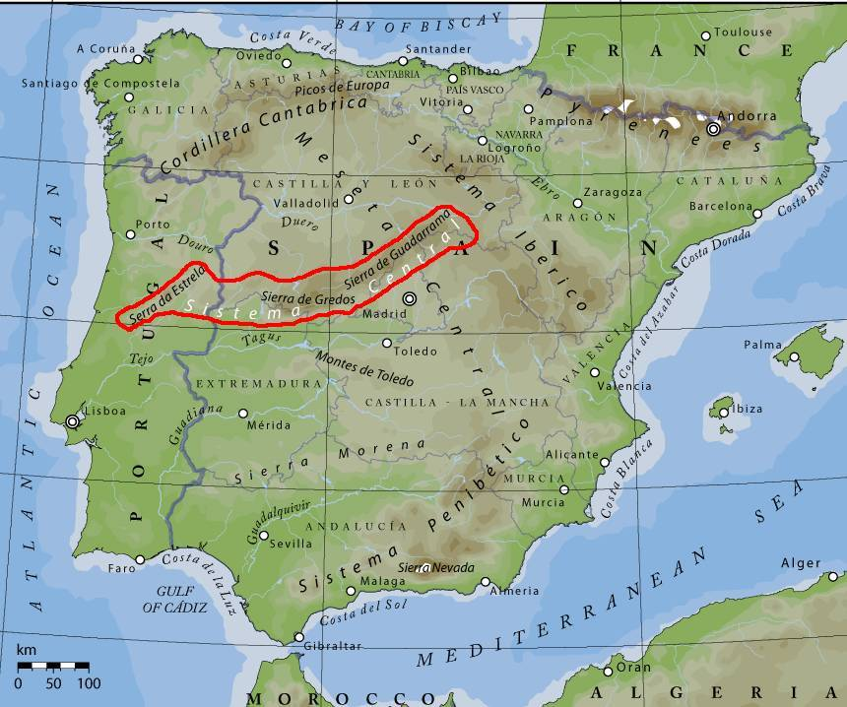

**Figure 1.** Map of Sierra de Guadarrama located within the Sistema Central Central Spain (Morley, 2011)

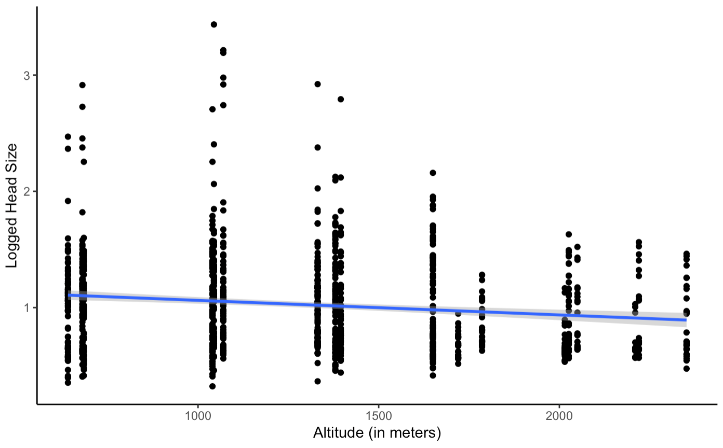

**Figure 2.** Linear regression visually representing the change in log ant head size (in mm) over altitude (in meters) across all recorded species ($R^{2}$ = 0.194) (Guzman, 2022).

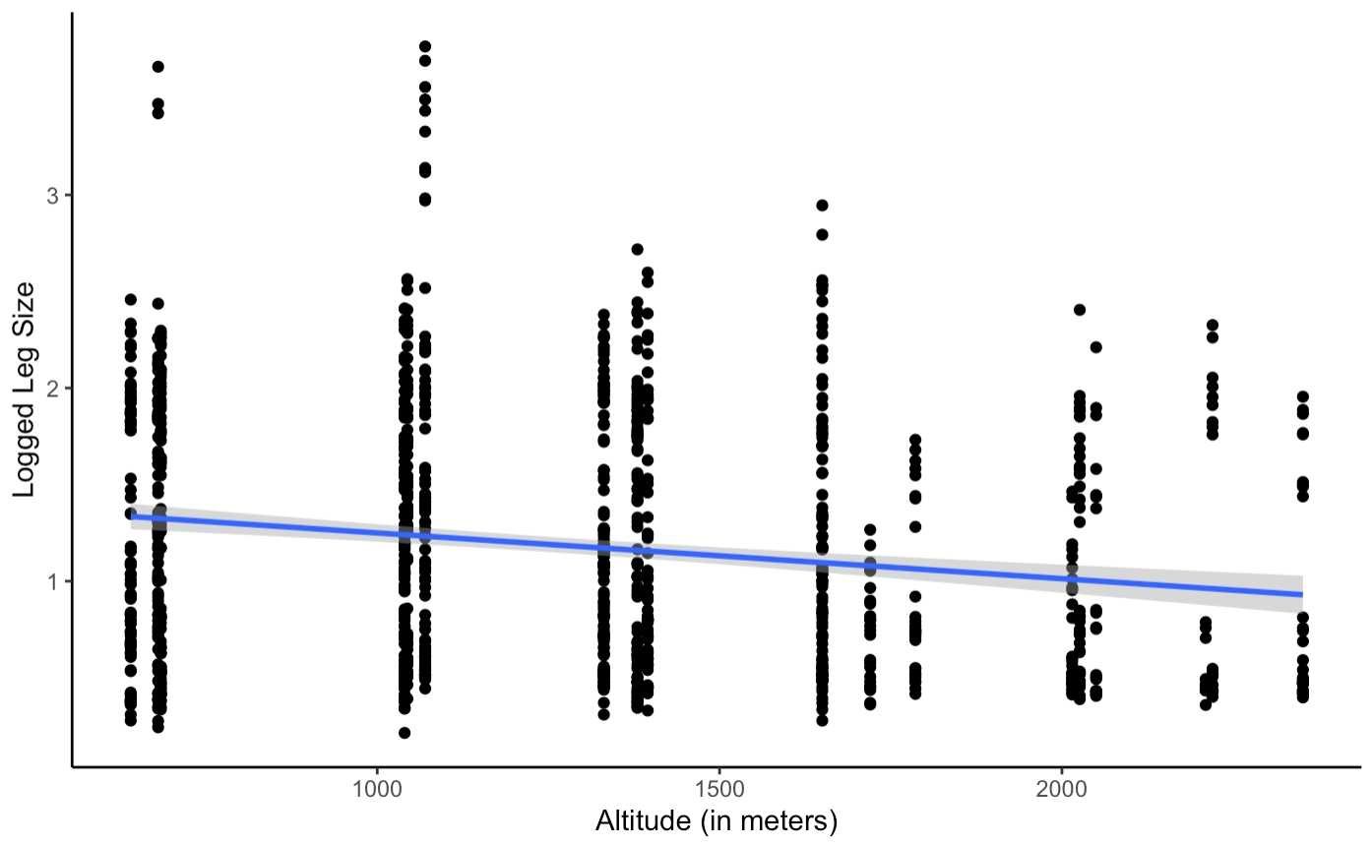

**Figure 3.** Linear regression visually representing the change in log ant leg size (in mm) over altitude (in meters) across all recorded species ($R^{2}$ = 0.027) (Guzman, 2022).

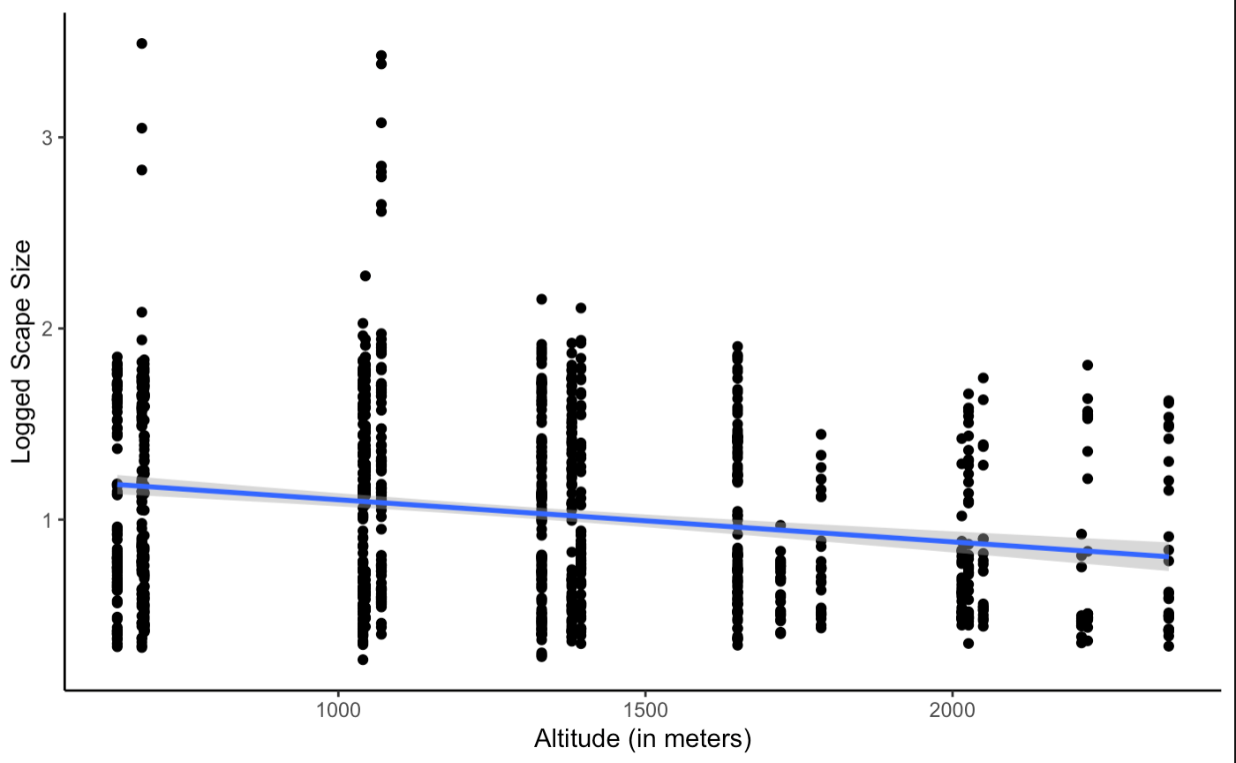

**Figure 4.** Linear regression visually representing the change in log scape size (in mm) over altitude (in meters) across all recorded species ($R^{2}$ = 0.04) (Guzman, 2022).

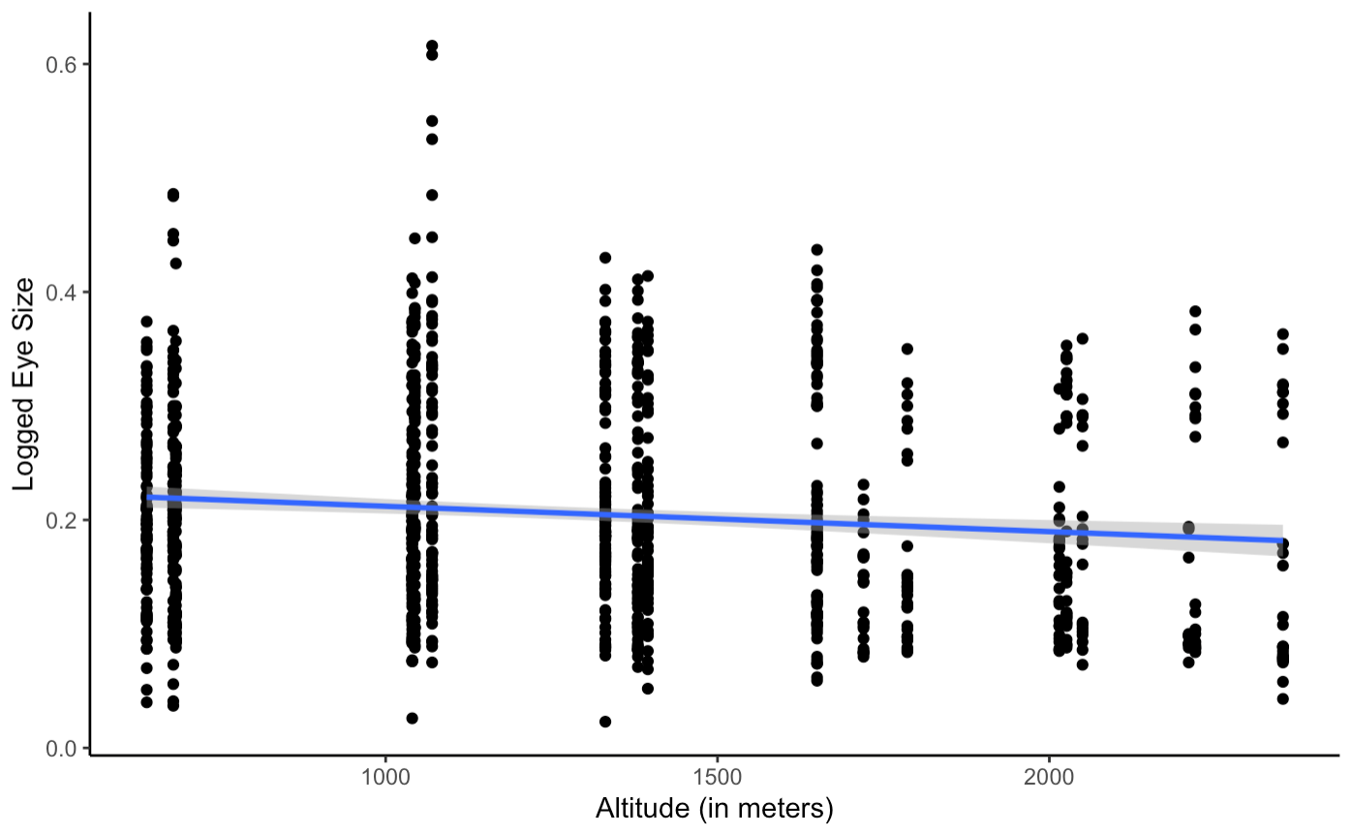

**Figure 5.** Linear regression visually representing the change in log ant eye size (in mm) over altitude (in meters) across all recorded species ($R^{2}$ = 0.119) (Guzman, 2022).

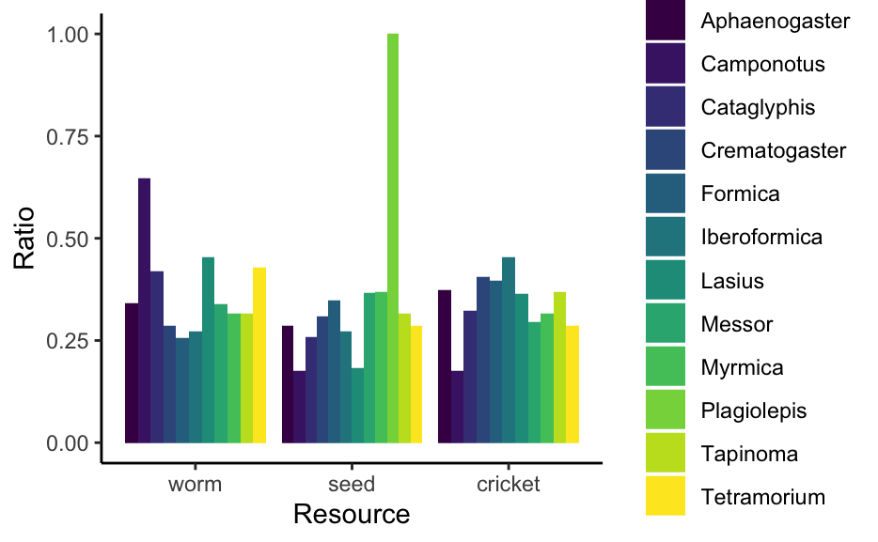

**Figure 6.** Histogram of the average preferred resource ratio across all genus for the worm, seed and cricket resources (Guzman, 2022).

**Table 1.** Statistical results showing the p-values, standard error (ER), degrees of freedom (DF) as well as $R^{2}$ values for the linear model performed for Hypothesis 1 (Guzman, 2022).

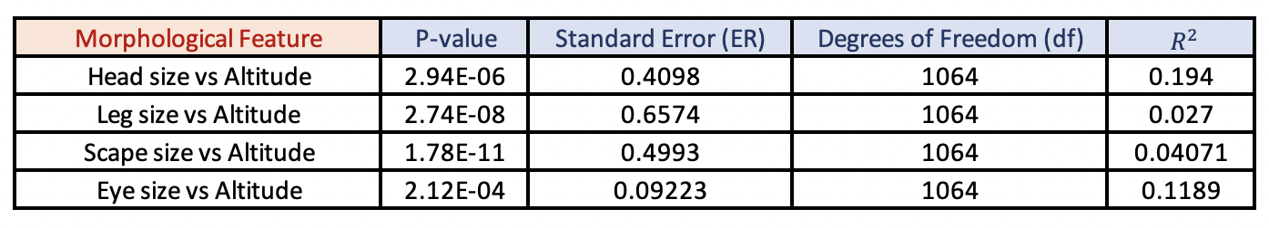

**Table 2.** ANOVA tests results for Hypothesis 2 (Guzman, 2022).

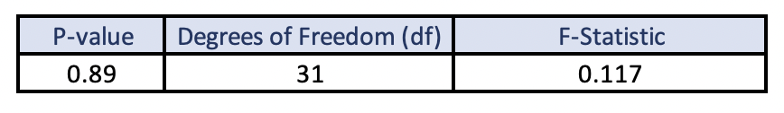

**Literature Cited**

*\*Original papers and datasets*

Ali Jan Ghasab, M., Khamis, S., Mohammad, F., & Jahani Fariman, H. (2015). Feature decision-making ant colony optimization system for an automated recognition of plant species. *Expert Systems with Applications*, *42*(5), 2361–2370.<https://doi.org/10.1016/j.eswa.2014.11.011>

Bernays, E. A., & Minkenberg, O. P. (1997). Insect herbivores: Different reasons for being a generalist. *Ecology*, *78*(4), 1157–1169. [https://doi.org/10.1890/0012-9658(1997)078[1157:ihdrfb]2.0.co;2](https://doi.org/10.1890/0012-9658(1997)078%5B1157:ihdrfb%5D2.0.co;2)

Bertness, M. D. (1981). Competitive dynamics of a tropical hermit crab assemblage. *Ecology*, *62*(3), 751–761. <https://doi.org/10.2307/1937743>

Chaki, J., & Parekh, R. (2011). Plant Leaf Recognition using Shape based Features and Neural Network classifiers. *International Journal of Advanced Computer Science and Applications*, *2*(10).<https://doi.org/10.14569/IJACSA.2011.021007>

Chown, S. L., & Gaston, K. J. (2010). Body size variation in insects: A macroecological perspective. *Biological Reviews*, *85*(1), 139–169.<https://doi.org/10.1111/j.1469-185X.2009.00097.x>

De Almeida Jácomo, A. T., Silveira, L., & Diniz-Filho, J. A. F. (2004). Niche separation between the maned wolf (Chrysocyon brachyurus), the crab-eating fox (Dusicyon thous) and the hoary fox (Dusicyon vetulus) in central Brazil. *Journal of Zoology*, *262*(1), 99–106.<https://doi.org/10.1017/S0952836903004473>

Dullinger, S., Gattringer, A., Thuiller, W., Moser, D., Zimmermann, N. E., Guisan, A., Willner, W., Plutzar, C., Leitner, M., Mang, T., Caccianiga, M., Dirnböck, T., Ertl, S., Fischer, A., Lenoir, J., Svenning, J.-C., Psomas, A., Schmatz, D. R., Silc, U., … Hülber, K. (2012). Extinction debt of high-mountain plants under twenty-first-century climate change. *Nature Climate Change*, *2*(8), 619–622. <https://doi.org/10.1038/nclimate1514>

Farji-Brener, A. G., Barrantes, G., & Ruggiero, A. (2004). Environmental rugosity, body size and access to food: A test of the size-grain hypothesis in tropical litter ants. *Oikos*, *104*(1), 165–171.<https://doi.org/10.1111/j.0030-1299.2004.12740.x>

Gibb, H., & Parr, C. L. (2013). Does Structural Complexity Determine the Morphology of Assemblages? An Experimental Test on Three Continents. *PLOS ONE*, *8*(5), e64005.<https://doi.org/10.1371/journal.pone.0064005>

Haub, G. (2021). Sierra de Guadarrama. summitpost.org. <https://www.summitpost.org/sierra-de-guadarrama/1029560>

Joseph, G. S., Muluvhahothe, M. M., Seymour, C. L., Munyai, T. C., Bishop, T. R., & Foord, S. H. (2019). Stability of Afromontane ant diversity decreases across an elevation gradient. *Global Ecology and Conservation*, *17*, e00596. <https://doi.org/10.1016/j.gecco.2019.e00596>

Ma, X., Lu, X., & Merilä, J. (2009). Altitudinal decline of body size in a Tibetan frog. *Journal of Zoology*, *279*(4), 364–371. <https://doi.org/10.1111/j.1469-7998.2009.00627.x>

Meiri, S., & Dayan, T. (2003). On the validity of Bergmann's rule. *Journal of Biogeography*, *30*(3), 331–351. <https://doi.org/10.1046/j.1365-2699.2003.00837.x>

Morley, R. (2011, July 13). Spain rocks. <http://aviewofmadrid.blogspot.com/2011/07/spain-rocks.html>

Reguera, S., Zamora-Camacho, F. J., & Moreno-Rueda, G. (2014). The lizard Psammodromus Algirus is darker at high altitudes. *Biological Journal of the Linnean Society*, *112*(1), 132–141. <https://doi.org/10.1111/bij.12250>

Rodriguez-Morata, C., Ballesteros-Cánovas, J. A., Trappmann, D., Beniston, M., & Stoffel, M. (2016). Regional Reconstruction of Flash Flood history in the Guadarrama Range (Central System, Spain). *Science of The Total Environment*, *550*, 406–417. <https://doi.org/10.1016/j.scitotenv.2016.01.074>

Salas-López, A. (2017). Predicting resource use in ant species and entire communities by studying their morphological traits: Influence of habitat and subfamily. *Ecological Indicators*, *78*, 183–191.<https://doi.org/10.1016/j.ecolind.2017.02.034>

Scott, G. R. (2011). Elevated performance: The unique physiology of birds that fly at high altitudes. *Journal of Experimental Biology*, *214*(15), 2455–2462. <https://doi.org/10.1242/jeb.052548>

Sears, M. W. (2004). Body size clines in sceloporus lizards: Proximate mechanisms and demographic constraints. *Integrative and Comparative Biology*, *44*(6), 433–442. <https://doi.org/10.1093/icb/44.6.433>

*Seoane, J., Azcárate, F. M., Silvestre, M., Hevia, V., and Ariño R. (2021). Ants in Guadarrama Range [data set]. Figshare. <https://doi.org/10.6084/m9.figshare.13246619.v1>

*Seoane, J., Silvestre, M., Hevia, V., Ariño R., and Azcárate, F. M. (2021, May). Abiotic controls, but not species richness, shape niche overlap and breadth of ant assemblages along an elevational gradient in Central Spain. *Acta Oecologica, Vol. 110*. <https://doi.org/10.1016/j.actao.2020.103695>

*Seoane, J., Silvestre, M., Hevia, V., Ariño R., and Azcárate, F. M. (2021). Morphological data for ants in Guadarrama Range (central Spain) [data set]. Figshare. <https://doi.org/10.6084/m9.figshare.14596065.v1>

*Silvestre, M., Carmona, C. P., Azcárate, F. M., & Seoane, J. (2021). Diverging facets of grassland ant diversity along a Mediterranean elevational gradient. *Ecological Entomology*, *46*(6), 1301–1314.<https://doi.org/10.1111/een.13077>

Yu, T. L., Wang, D. L., Busam, M., & Deng, Y. H. (2019). Altitudinal variation in body size in Bufo minshanicus supports Bergmann’s rule. *Evolutionary Ecology*, *33*(3), 449–460. <https://doi.org/10.1007/s10682-019-09984-1>

Zamora-Camacho, F. J., Reguera, S., & Moreno-Rueda, G. (2014). Bergmann's rule rules body size in an ectotherm: Heat conservation in a lizard along a 2200-metre elevational gradient. *Journal of Evolutionary Biology*, *27*(12), 2820–2828. <https://doi.org/10.1111/jeb.12546>

**Case Study Link**

[Case Study](https://docs.google.com/presentation/d/1H3_t8dIuRz_ees4Pjp9Px-c8N6MXTJWYCBa63lgdVsA/edit?usp=sharing)